**FLOWCHAT FOR AIR QUALITY:**

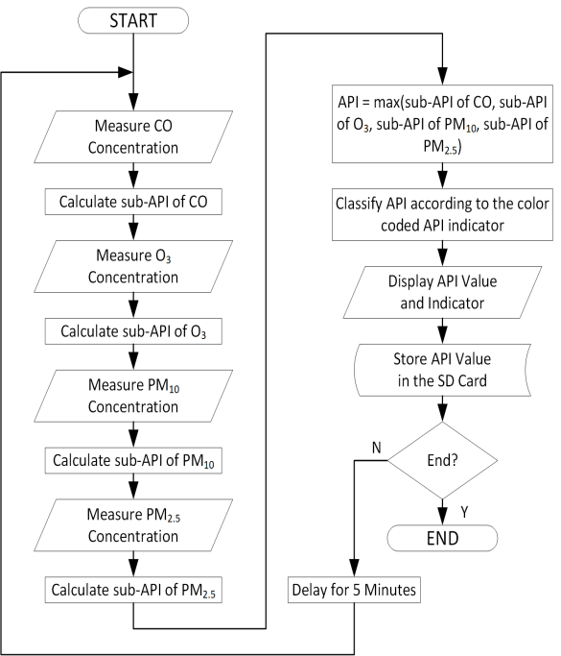

**The use of multi-parameter air quality monitoring systems makes it possible to do a detailed level analysis of major pollutants and their sources.**

**These monitoring systems are important components in many smart city projects for monitoring air quality and for controlling the main pollutant concentrations in urban areas.**

**Air quality management**

ATTRIBUTES FOR AIR QUALITY MANAGEMENT

PARAMETER

A parameter is contextually declared with the parameter attribute by its specification in a PROCEDURE or ENTRY statement. The parameter should be explicitly declared with appropriate attributes. The PARAMETER attribute can also be specified in the declaration

UNITS

* Not vary with respect to place.
* Not vary with respect to time.
* Be of Convenient size.
* Easy to make a copy.
* Be properly defined.
* Reproduce easily.
* Be easy to measure things. etc.

CATIONS

Characteristics of cations : (i) Cations are positively charged. (ii) Cations are formed when an atom loses electrons from its valence shell to attain octet. (iii) Cations are smaller in size than parent atom. (iv) The charge acquired by a cation is equal to the number of electrons lost by the valence shell

SYMBOLS

A chemical symbol is a one- or two-letter designation of an element. Some examples of chemical symbols are O for oxygen, Zn for zinc, and Fe for iron. The first letter of a symbol is always capitalized. If the symbol contains two letters, the second letter is lower case.

|  |  |  |  |  |
| --- | --- | --- | --- | --- |
| **Parameter** | **Unit** | **N01** | **N02** | **N04** |
| COD | ppm | 18 | 21 |  |
| hardnessCaC03 | ppm | 397.5 | 353.5 | 3 |
| Si02 | ppm | 2.88 | 3.84 | 4 |
| Organicnitrogen | ppm | 3.27 | 0.54 | 1 |
| Totalnitrogen | ppm | 4.96 | 1.17 | 1 |
| Fe | ppm | 0.062 | 0.017 | 0 |
| 804 | ppm | 248.2 | 176.2 | 1 |
| NH3 | ppm | 0.4 | 2.01 | 0 |
| Cl | ppm | 251 | 340.8 | 37 |
| Nitrate | ppm | 6 | 2.98 | 3 |
| OrganicPhosphate | ppm | 0.031 | 0.021 | 0 |
| TotalPhosphorus | ppm | 0.058 | 0.025 | 1 |
| TSS | ppm | 1426 | 88 | 2 |
| Turbidity | NTU | 18.52 | 43 | 45 |
| pH | ppm | 8.5 | 8.2 | 26 |
| EC | µSem | 1426 | 1620 | 1 |
| Temperature | OC | 14 | 13 | 11 |
| BOD5 | ppm | 3.2 | 3.5 | 08 |
| DO | ppm | 8 | 9.8 | 34 |
| Springsname | 7.3 | 1182 | 3200 3117 | 842.14 |
| tfaatook-2 | 7.4 | 1064 | 2900 2790 | 741.9 |
| laan-3 | 7.2 | 944 | 2561 2390 | 721.9 |
| Al-rohbaan-4 | 7.2 | 986 | 2390 2203 | 731.9 |
| Al-hiaiatheea-5 | 7.8 | 1001 | 2320 2237 | 541.4 |
| M-rehameah-6 | 7.6 | 1276 | 2690 2412 | 411.03 |
| Al-iseaah-7 | 7.6 | 1245 | 2864 2710 | 481.2 |
| Al-assaweed-8 | 7.4 | 1387 | 2813 2931 | 561.4 |
| Al-ruhhba-9 | 7.3 | 1681 | 2890 2701 | 441.1 |
| Rweez-10 | 7.4 | 1512 | 2864 2682 | 461.2 |
| Average | 7.4 | 1228 | 2759 2597 | 59 |

|  |  |  |  |  |
| --- | --- | --- | --- | --- |
|  | **To convertppm‘as theion’toppm‘as CaC03’mulit** | | | |
| 0 | **Cations** | symbol | values | T |
| 16.5 | Aluminum | Al3* | 5.55 | pH |
| .13 | Ammonium | NH4* | 2.78 | EC |
| 1.26 | Barium | Ba2* | 0.73 | SS |
| .12 | Cadmium | Cd2* | 1.78 | MAl |
| .03 | Calcium | Ca2* | 2.5 | Cl |
| 12.8 | Chromium | Cr3* | 2.89 | NH3-N |
| .34 | Copper | Cu2* | 1.57 | N03-N |
| 7.01 | Ferric (Iron) | Fe3* | 2.69 | DO |
| .14 | Ferrous(Iron) | Fe2* | 1.79 | Pv |
| .14 | Hydrogen | H* | 50 | BODs |
| .67 | Lead | Pb2* | 0.48 | T |
| 66 | Magnesium | Mg2* | 4.1 | pH |
| 6 | Nickel | Ni2* | 3.16 | EC |
| 8.1 | Potassium | K* | 1.28 | SS |
| 730 | Silver | Ag* | 0.93 | MAl |
| 10 | Sodium | Na* | 2.18 | Cl |
| 4.4 | Zinc | Zn2* | 1.53 | NH3-N |
| 8.6 | Copper | Cu2* | 11.26 | N03-N |
| 45719.8 | 17314.2 | 1889.4 | 95226. | 66013.7 |
| 34815.1 | 917.4 | 27613.8 | 86824. | 54811.4 |
| 38216.6 | 766.3 | 25212.6 | 58816. | 56011.7 |
| 2038.8 | 574.7 | 30115 | 46213 | 78516.3 |
| 27812.1 | 463.8 | 32616.3 | 46213 | 83017.3 |
| 26311.4 | 19616.2 | 1889.4 | 38010. | 118824.7 |
| 33514.6 | 21317.5 | 1527.4 | 54615. | 122625.5 |
| 266 | 25120.6 | 1437.1 | 71420. | 97020.2 |
| 27111.9 | 34228.2 | 1125.6 | 350 | 176536.8 |
| 266 | 31926.2 | 1316.6 | 392 | 153932.1 |
| 307 | 176 | 207 | 571 | 1007 |

|  |  |  |  |  |  |
| --- | --- | --- | --- | --- | --- |
| -0.734 | 0.539 | -0.238 | 0.075 | 0.018 | 0.0 |
| -0.088 | 0.061 | -0.246 | 0.472 | 0.032 | -0. |
| -0.821 | 0.312 | -0.067 | 0.079 | -0.203 | -0. |
| 0.644 | 0.575 | -0.264 | -0.003 | 0.149 | 0.2 |
| -0.463 | -0.380 | 0.357 | 0.083 | 0.682 | 0.0 |
| -0.183 | 0.372 | 0.646 | -0.349 | -0.028 | 0.3 |
| 0.097 | 0.565 | 0.641 | -0.037 | 0.007 | -0. |
| 0.029 | -0.378 | -0.163 | -0.775 | -0.096 | 0.0 |
| 0.659 | -0.623 | 0.113 | 0.067 | -0.017 | -0. |
| 0.524 | 0.675 | 0.061 | -0.120 | 0.096 | -0. |
| 0.467 | -0.176 | 0.539 | 0.421 | -0.295 | 0.2 |
| -0.734 | 0.539 | -0.238 | 0.075 | 0.018 | 0.0 |
| -0.088 | 0.061 | -0.246 | 0.472 | 0.032 | -0. |
| -0.821 | 0.312 | -0.067 | 0.079 | -0.203 | -0. |
| 0.644 | 0.575 | -0.264 | -0.003 | 0.149 | 0.2 |
| -0.463 | -0.380 | 0.357 | 0.083 | 0.682 | 0.0 |
| -0.183 | 0.372 | 0.646 | -0.349 | -0.028 | 0.3 |
| 0.097 | 0.565 | 0.641 | -0.037 | 0.007 | -0. |
| 0.029 | -0.378 | -0.163 | -0.775 | -0.096 | 0.0 |
| 1161.9 | 25 | 0.641 | -0.037 | 0.007 | -0. |
| 451.5 | 26 | -0.163 | -0.775 | -0.096 | 0.0 |
| 1161.9 | 26 | 0.113 | 0.067 | -0.017 | -0. |
| 1161.9 | 25.5 | 0.061 | -0.120 | 0.096 | -0. |
| 1402.3 | 26 | 0.539 | 0.421 | -0.295 | 0.2 |
| 1101.8 | 26.5 | -0.238 | 0.075 | 0.018 | 0.0 |
| 1221.99 | 27 | -0.246 | 0.472 | 0.032 | -0. |
| 1161.9 | 26 | -0.067 | 0.079 | -0.203 | -0. |
| 1091.8 | 26 | -0.264 | -0.003 | 0.149 | 0.2 |
| 116 | 25.6 | 0.357 | 0.083 | 0.682 | 0.0 |
| 109 | 25 | 0.646 | -0.349 | -0.028 | 0.3 |

|  |  |  |  |  |  |  |  |  |
| --- | --- | --- | --- | --- | --- | --- | --- | --- |
|  |  |  |  |  |  |  |  |  |
| 84 | 0.182 | 0.023 | -0.037 | 0.170 | -0.191 | -0.238 | 0.075 | 0.018 |
| 041 | -0.035 | 0.113 | 0.006 | 0.013 | 0.038 | -0.246 | 0.472 | 0.032 |
| 028 | 0.206 | -0.160 | 0.304 | -0.065 | 0.103 | -0.067 | 0.079 | -0.203 |
| 51 | 0.066 | 0.110 | 0.052 | 0.158 | 0.162 | -0.264 | -0.003 | 0.149 |
| 85 | 0.179 | -0.025 | 0.016 | -0.015 | 0.026 | 0.357 | 0.083 | 0.682 |
| 23 | -0.274 | -0.029 | 0.124 | 0.032 | -0.032 | 0.646 | -0.349 | -0.028 |
| 450 | 0.095 | 0.213 | 0.032 | 0.035 | 0.015 | 0.641 | -0.037 | 0.007 |
| 26 | 0.307 | 0.114 | -0.015 | 0.003 | 0.014 | -0.163 | -0.775 | -0.096 |
| 161 | 0.023 | -0.174 | 0.220 | 0.208 | -0.048 | 0.113 | 0.067 | -0.017 |
| 091 | 0.131 | -0.349 | -0.184 | -0.030 | 0.009 | 0.061 | -0.120 | 0.096 |
| 98 | 0.316 | 0.041 | -0.060 | -0.041 | -0.026 | 0.539 | 0.421 | -0.295 |
| 84 | 0.182 | 0.023 | -0.037 | 0.170 | -0.191 | -0.238 | 0.075 | 0.018 |
| 041 | -0.035 | 0.113 | 0.006 | 0.013 | 0.038 | -0.246 | 0.472 | 0.032 |
| 028 | 0.206 | -0.160 | 0.304 | -0.065 | 0.103 | -0.067 | 0.079 | -0.203 |
| 51 | 0.066 | 0.110 | 0.052 | 0.158 | 0.162 | -0.264 | -0.003 | 0.149 |
| 85 | 0.179 | -0.025 | 0.016 | -0.015 | 0.026 | 0.357 | 0.083 | 0.682 |
| 23 | -0.274 | -0.029 | 0.124 | 0.032 | -0.032 | 0.646 | -0.349 | -0.028 |
| 450 | 0.095 | 0.213 | 0.032 | 0.035 | 0.015 | 0.641 | -0.037 | 0.007 |
| 26 | 0.307 | 0.114 | -0.015 | 0.003 | 0.014 | -0.163 | -0.775 | -0.096 |
| 450 | 0.095 | 0.213 | 0.032 | 0.035 | 0.015 | 0.641 | -0.037 | 0.007 |
| 26 | 0.307 | 0.114 | -0.015 | 0.003 | 0.014 | -0.163 | -0.775 | -0.096 |
| 161 | 0.023 | -0.174 | 0.220 | 0.208 | -0.048 | 0.113 | 0.067 | -0.017 |
| 091 | 0.131 | -0.349 | -0.184 | -0.030 | 0.009 | 0.061 | -0.120 | 0.096 |
| 98 | 0.316 | 0.041 | -0.060 | -0.041 | -0.026 | 0.539 | 0.421 | -0.295 |
| 84 | 0.182 | 0.023 | -0.037 | 0.170 | -0.191 | -0.238 | 0.075 | 0.018 |
| 041 | -0.035 | 0.113 | 0.006 | 0.013 | 0.038 | -0.246 | 0.472 | 0.032 |
| 028 | 0.206 | -0.160 | 0.304 | -0.065 | 0.103 | -0.067 | 0.079 | -0.203 |
| 51 | 0.066 | 0.110 | 0.052 | 0.158 | 0.162 | -0.264 | -0.003 | 0.149 |
| 85 | 0.179 | -0.025 | 0.016 | -0.015 | 0.026 | 0.357 | 0.083 | 0.682 |
| 23 | -0.274 | -0.029 | 0.124 | 0.032 | -0.032 | 0.646 | -0.349 | -0.028 |

|  |  |  |
| --- | --- | --- |
|  |  |  |
| 0.084 | | 7.28 |
| -0.041 | | 5.55 |
| -0.028 | | 2.78 |
| 0.251 | | 0.73 |
| 0.085 | | 1.78 |
| 0.323 | | 2.5 |
| -0.450 | | 2.89 |
| 0.026 | | 1.57 |
| -0.161 | | 2.69 |
| -0.091 | | 1.79 |
| 0.298 | | 50 |
| 0.084 | | 0.48 |
| -0.041 | | 4.1 |
| -0.028 | | 3.16 |
| 0.251 | | 1.28 |
| 0.085 | | 0.93 |
| 0.323 | | 2.18 |
| -0.450 | | 1.53 |
| 0.026 | | 11.26 |
| -0.450 | | 95226.9 |
| 0.026 | | 86824.5 |
| -0.161 | | 58816.5 |
| -0.091 | | 46213 |
| 0.298 | | 46213 |
| 0.084 | | 38010.7 |
| -0.041 | | 54615.4 |
| -0.028 | | 71420.1 |
| 0.251 | | 350 |
| 0.085 | | 392 |
| 0.323 | | 571 |

Air quality management

Program(python):

#define BLYNK_TEMPLATE_ID "TMPLwToQUqRw"

#define BLYNK_TEMPLATE_NAME "Air Quality Management"

#define BLYNK_AUTH_TOKEN "C8Y7T0Fr54QF8pdfQ5dZsdfhhSdiQBFLj8mYe"

#define BLYNK_PRINT **Serial**

#include <WiFi.h>

#include <BlynkSimpleEsp32.h>

#include <DHT.h>

#include <LiquidCrystal_I2C.h>

LiquidCrystal_I2C lcd(0x27, 16, 2);

  byte degree_symbol[8] =

              {

                0b00111,

                0b00101,

                0b00111,

                0b00000,

                0b00000,

                0b00000,

                0b00000,

                0b00000

              };

char auth[] = BLYNK_AUTH_TOKEN;

char ssid[] = "WiFi Username";  // type your wifi name

char pass[] = "WiFi Password";  // type your wifi password

BlynkTimer timer;

int gas = 32;

int sensorThreshold = 100;

#define DHTPIN 2 //Connect Out pin to D2 in NODE MCU

#define DHTTYPE DHT11

DHT dht(DHTPIN, DHTTYPE);

void sendSensor()

{

  float h = dht.readHumidity();

  float t = dht.readTemperature(); // or dht.readTemperature(true) for Fahrenheit

     if (isnan(h) || isnan(t)) {

**Serial**.println("Failed to read from DHT sensor!");

    return;

  }

   int analogSensor = analogRead(gas);

  Blynk.virtualWrite(V2, analogSensor);

**Serial**.print("Gas Value: ");

**Serial**.println(analogSensor);

  // You can send any value at any time.

  // Please don't send more that 10 values per second.

    Blynk.virtualWrite(V0, t);

    Blynk.virtualWrite(V1, h);

**Serial**.print("Temperature : ");

**Serial**.print(t);

**Serial**.print("    Humidity : ");

**Serial**.println(h);

}

void setup()

{

**Serial**.begin(115200);

 //pinMode(gas, INPUT);

  Blynk.begin(auth, ssid, pass);

  dht.begin();

  timer.setInterval(30000L, sendSensor);

 //Wire.begin();

   lcd.begin(16,2);

//  lcd.backlight();

 // lcd.clear();

  lcd.setCursor(3,0);

  lcd.print("Air Quality");

  lcd.setCursor(3,1);

  lcd.print("Management");

  delay(2000);

  lcd.clear();

  }

Output:

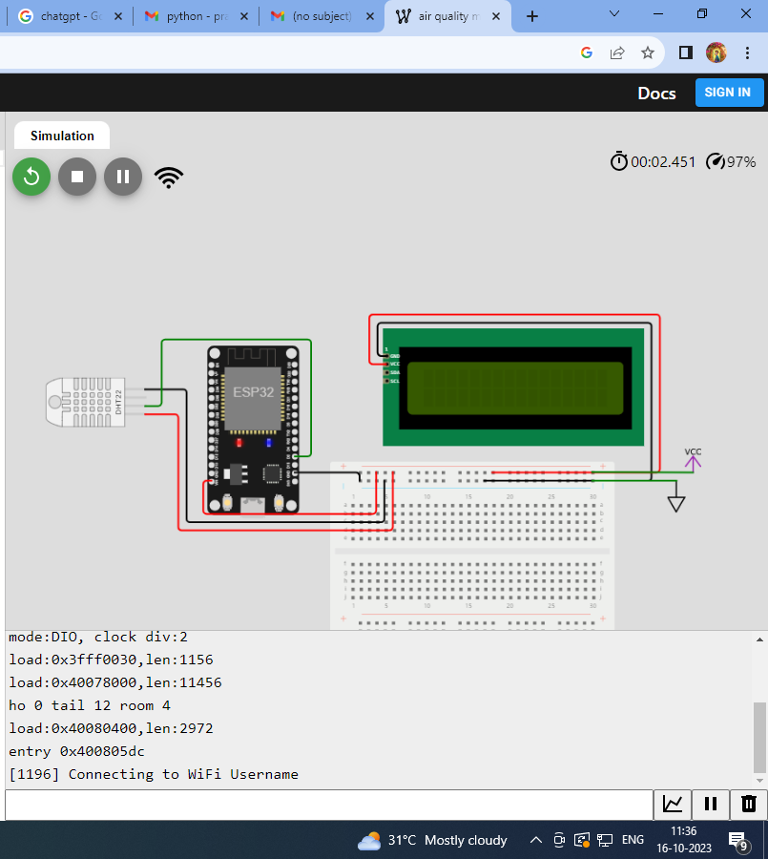

AIR QUALITY MANAGEMENT

PROGRAM(Python):

from machine import Pin

from time import sleep

import dht

import network

sta_if = network.WLAN(network.STA_IF)

if not sta_if.isconnected():

print('connecting to network...')

sta_if.active(True)

sta_if.connect('Wokwi-GUEST', "")

while not sta_if.isconnected():

pass

print('network config:', sta_if.ifconfig())

sensor = dht.DHT22(Pin(15))

while True:

try:

sleep(2)

sensor.measure()

temp = sensor.temperature()

hum = sensor.humidity()

temp_f = temp * (9/5) + 32.0

print('Temperature: %3.1f C' %temp)

print('Temperature: %3.1f F' %temp_f)

print('Humidity: %3.1f %%' %hum)

except OSError as e:

print('Failed to read sensor.')

OUTPUT:

